**Jc313512 Manjinder Kaur Khosa**

**Project plan:**

**Goals:**

* To exceed the customer’s expectations
* To increase the number of clients by superior performance
* Keep the clients happy
* To introduce the clients with new products like how they can maintain itself.
* To give a professional look to the customers by professional haircuts and treatments.
* Satisfy the customers.

**Success Evaluation:**

1. Content: When our website will have the clear and relevant material like what it will do and offer then the visitors will care then our website will meet the business expectations.
2. Usability: Usability is all about the practical considerations of what goes into good website design like speed, user-friendly, security. If a visitor can’t find like what they are looking because of poor navigation then he or she may leave.
3. Style: Style of the website is most important thing. When it’s colours and styles will matches then it create positive impression for visitors.
4. Engagement:The length of time a visitor stays on a website is an important indication of whether the site is attracting the right type visitor and if it’s set up in an engaging way that keeps the visitor there to learn more.
5. Bounce Rate: Similar to engagement, this indicates the percentage of visitors who left the site without moving on to another page from the one they landed on. A high bounce rate means the site is failing to visitors to stay and learn more about the business.

### Target Audience:

* Female of all ages.

**Flow chart:**

**Home**

**Haircut**

**Treatments**

**Service**

**About**

**Contact**

**Face treatments**

**Appointment form**

**Hand & Feet treatments**

**Body massage**

**Hair treatments**

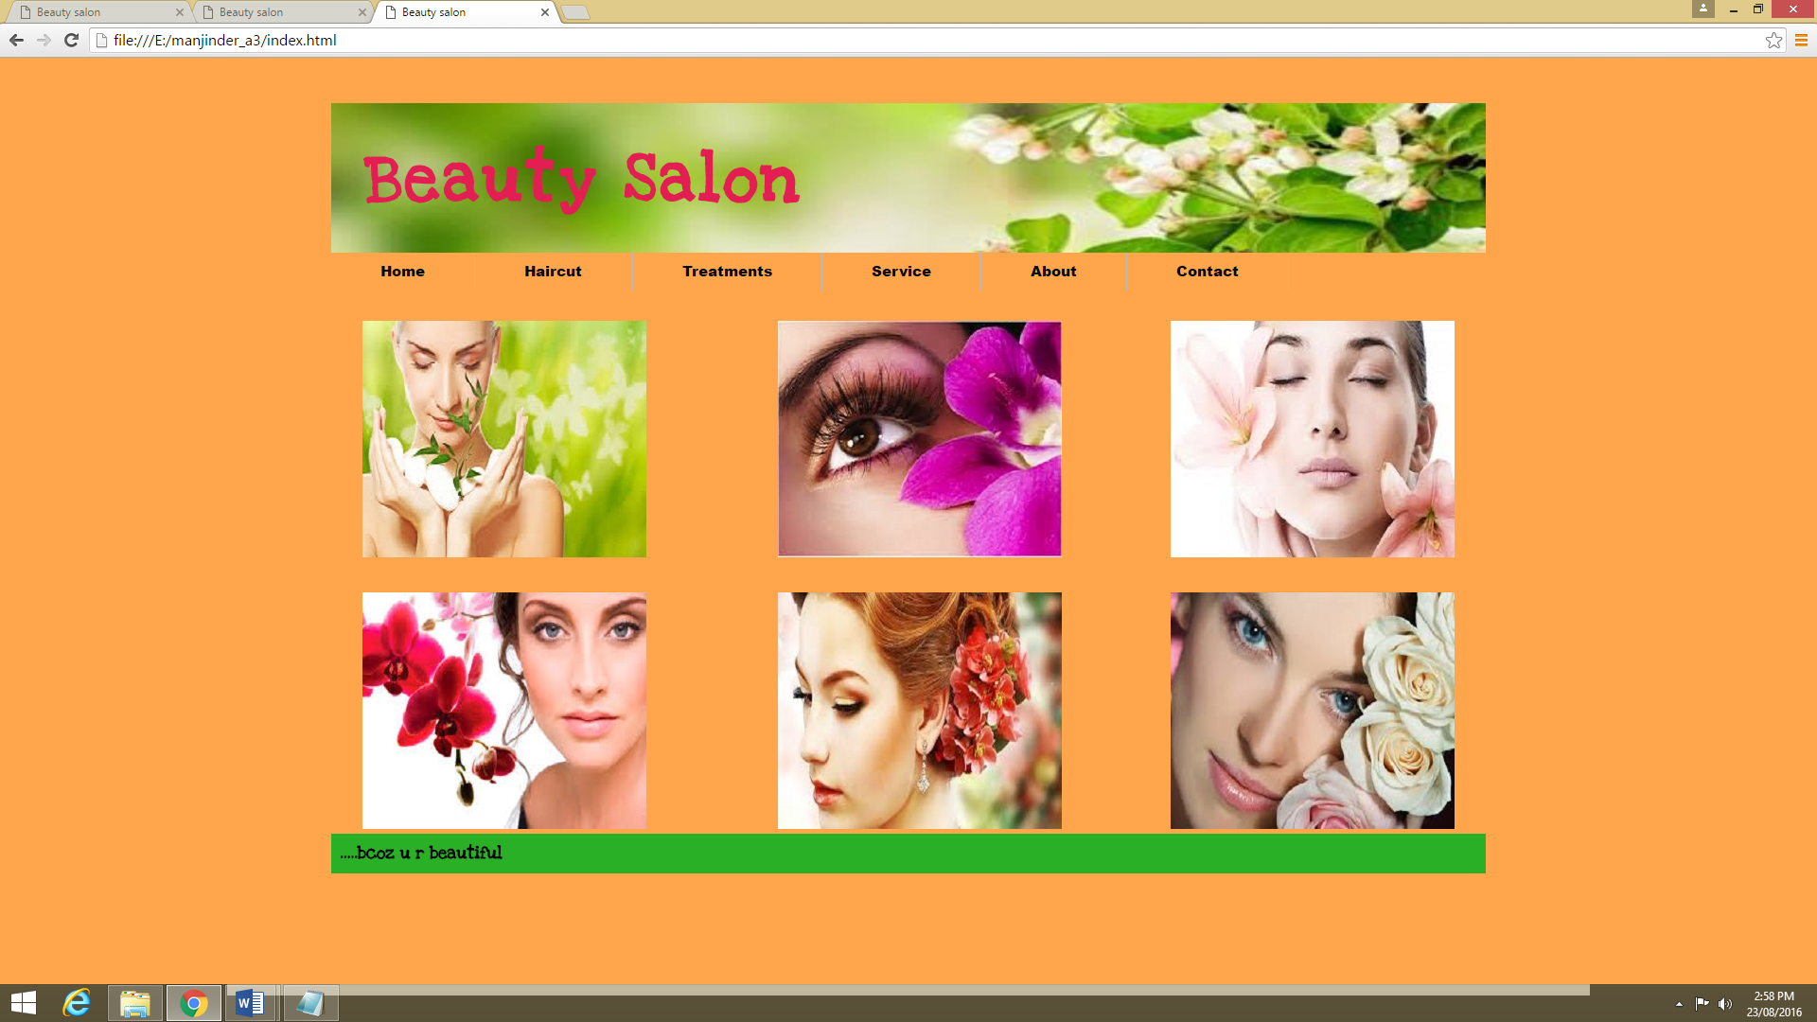 **Home page**

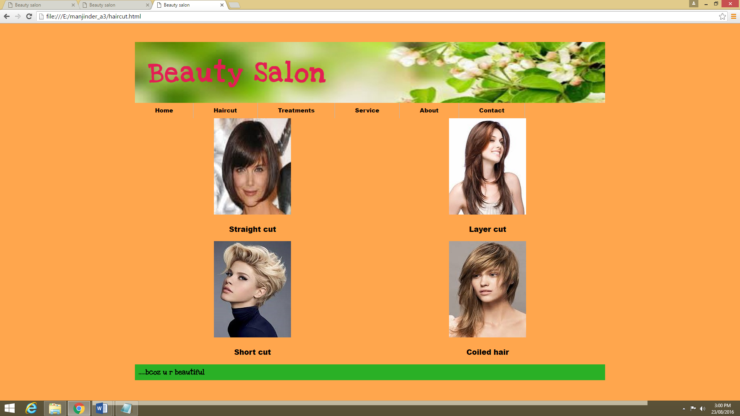**Haircut page**

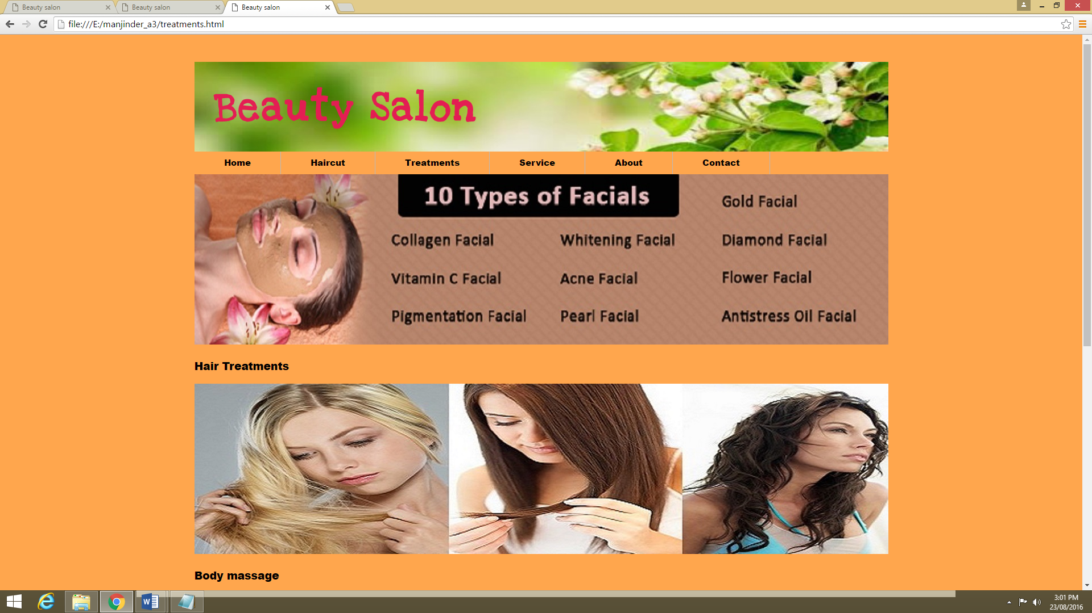**Treatments page**

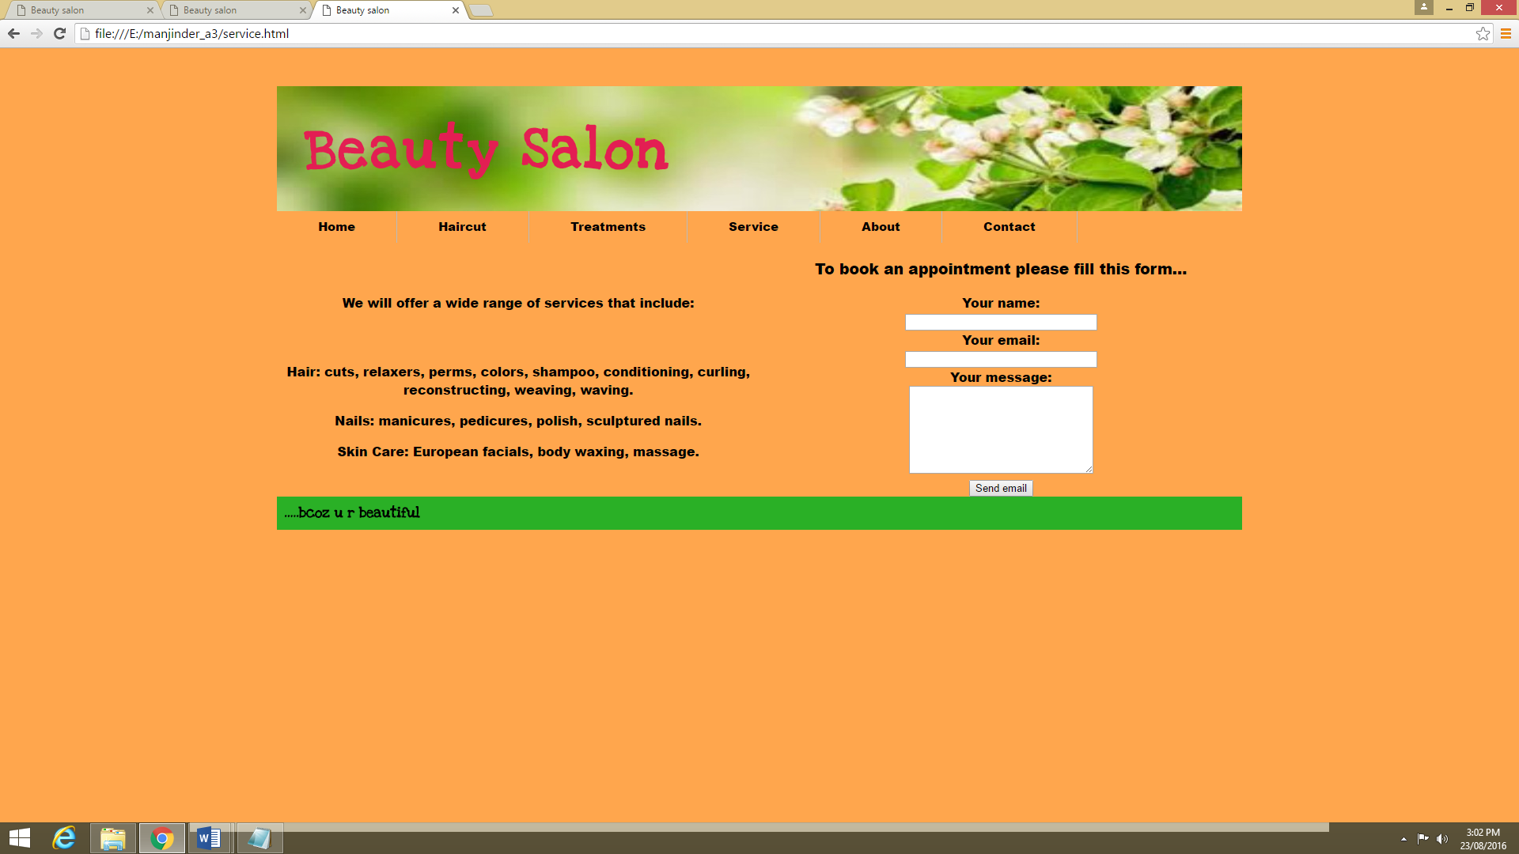**Service page**

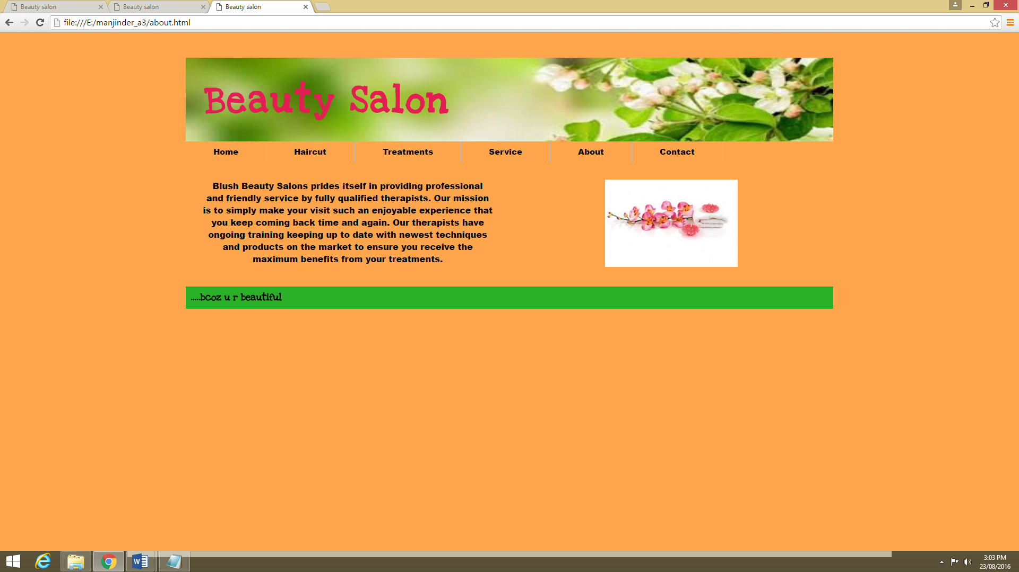**About page**

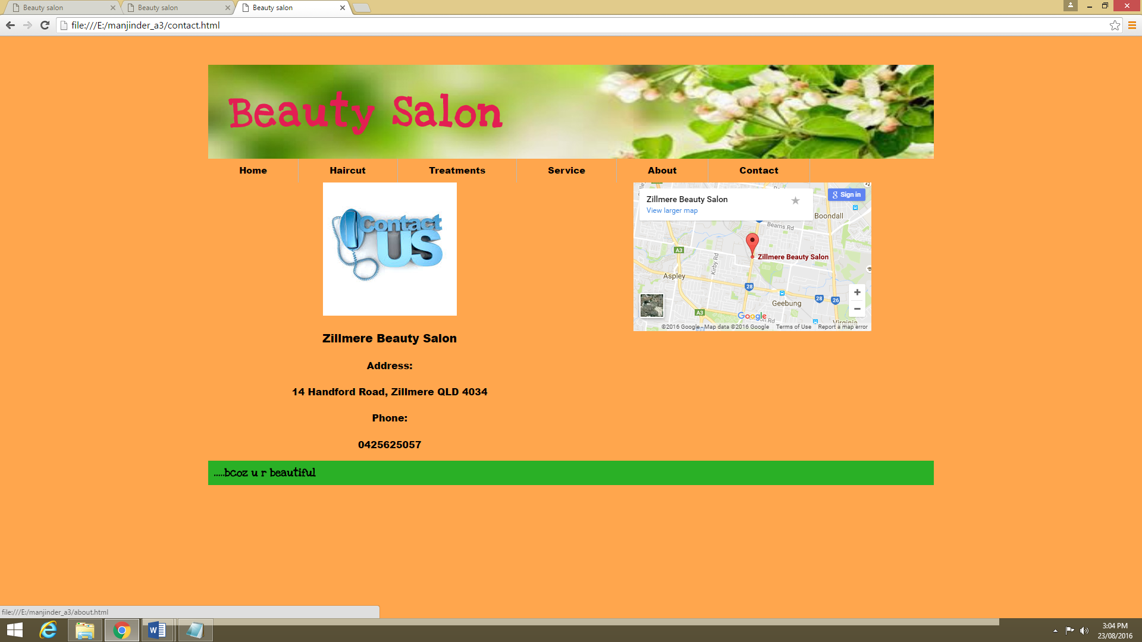**Contact page**